# Computer Networks and Architecture 05/08/2024

**Processor**: The processor is a chip or a logical circuit that responds and processes the basic instructions to drive a particular computer. The main functions of the processor are fetching, decoding, executing, and writing back the operations of an instruction. The ALU (Arithmetic Logic Unit) and CU (Control Unit) are the two parts of the processors. The Arithmetic Logic Unit performs all mathematical operations such as additions, multiplications, subtractions, divisions, etc and the control unit works like traffic police, it manages the command or the operation of the instructions. The processor communicates with the other components also; they are input/output devices and memory/storage devices.

## Types of Processors:

### Basic CPU Types:

* + CPU (Central Processing Unit): The fundamental processor in a PC. It consists of one or more processing cores running at a fixed clock speed (measured in MHz or GHz). Overclocking (running above the fixed frequency) is possible but requires more voltage and generates additional heat.
  + APU (CPU with Integrated Graphics): Some CPUs come with integrated graphics. Intel CPUs commonly include integrated graphics, while AMD’s APUs (Accelerated Processing Units) combine CPU cores with integrated GPUs. APUs are versatile, especially for desktop or editing use.

### CPU Types by Core/Thread Architecture:

* + **Single-Core CPU:** The original CPU design with a single core. While not commonly manufactured anymore, it laid the groundwork for multi-core CPUs.
  + **Multi-Core CPU:** Introduced in 2001, multi-core CPUs have multiple cores. The market has seen increasing core counts and IPC (Instructions Per Clock) competition.
  + **Multi-Threaded CPU:** These CPUs support simultaneous multi-threading (SMT) or hyper-threading. Each core can handle multiple threads, improving performance.
  + **Mainstream CPU:** General-purpose CPUs suitable for most tasks.
  + **Server and Workstation CPU:** Designed for enterprise use, offering high performance and reliability.
  + **HEDT CPU (High-End Desktop)**: Enthusiast-grade CPUs for demanding applications.
  + **Unlocked CPU:** Processors that allow overclocking beyond the fixed frequency.

### Other Processor Types:

* + **Microcontroller**: Used in embedded systems, IoT devices, and appliances.
  + **Microprocessor**: General-purpose CPUs found in computers.
  + **Embedded Processor**: Customized CPUs for specific applications.
  + **DSP (Digital Signal Processor**): Optimized for signal processing tasks.
  + **Media Processor**: Designed for multimedia applications.

## Types of Memory:

### 1. Primary Memory

* **RAM (Random Access Memory)**: Volatile memory used for temporary storage while the computer is running. Types include:
  + **DRAM (Dynamic RAM)**: Needs to be refreshed thousands of times per second.
  + **SRAM (Static RAM)**: Faster and more reliable but more expensive than DRAM.
* **ROM (Read-Only Memory)**: Non-volatile memory used to store firmware. Types include:
  + **PROM (Programmable ROM)**
  + **EPROM (Erasable Programmable ROM)**
  + **EEPROM (Electrically Erasable Programmable ROM)**

### 2. Secondary Memory

* **HDD (Hard Disk Drive)**: Magnetic storage for long-term data storage.
* **SSD (Solid-State Drive)**: Faster than HDDs, using flash memory.
* **Optical Discs**: CDs, DVDs, and Blu-ray discs for storing data using laser technology.

### 3. Cache Memory

* A small, high-speed memory located close to the CPU to speed up access to frequently used data.

### 4. Virtual Memory

* A section of a storage drive used as an extension of RAM to handle larger workloads.

## Popular Vendors of Processors:

* Intel
* Amd
* Apple
* Qualcomm

# 

# Binary to Decimal Conversion:

|  |  |  |  |  |  |  |  |  |
| --- | --- | --- | --- | --- | --- | --- | --- | --- |
| **128** | **64** | **32** | **16** | **8** | **4** | **2** | **1** | **Decimal Value** |
| 1 | 0 | 0 | 1 | 0 | 0 | 1 | 0 | **146** |
| 0 | 1 | 1 | 1 | 0 | 1 | 1 | 1 | **119** |
| 1 | 1 | 1 | 1 | 1 | 1 | 1 | 1 | **255** |
| 1 | 1 | 0 | 0 | 0 | 1 | 0 | 1 | **197** |
| 1 | 1 | 1 | 1 | 0 | 1 | 1 | o | **246** |
| 0 | 0 | 0 | 1 | 0 | 0 | 1 | 1 | **19** |
| 1 | 0 | 0 | 0 | 0 | 0 | 0 | 1 | **129** |
| 0 | 0 | 1 | 1 | 0 | 0 | 0 | 1 | **49** |
| 0 | 1 | 1 | 1 | 1 | 0 | 0 | 0 | **120** |
| 1 | 1 | 1 | 1 | 0 | 0 | 0 | 0 | **240** |
| 0 | 0 | 1 | 1 | 1 | 0 | 1 | 1 | **59** |
| 0 | 0 | 0 | 0 | 0 | 1 | 1 | 1 | **7** |
| 0 | 0 | 0 | 1 | 1 | 0 | 1 | 1 | **27** |
| 1 | 0 | 1 | 0 | 1 | 0 | 1 | 0 | **170** |
| 0 | 1 | 1 | 0 | 1 | 1 | 1 | 1 | **111** |
| 1 | 1 | 1 | 1 | 1 | 0 | 0 | 0 | **148** |
| 0 | 0 | 1 | 0 | 0 | 0 | 0 | 0 | **32** |
| 0 | 1 | 0 | 1 | 0 | 1 | 0 | 1 | **85** |
| 0 | 0 | 1 | 1 | 1 | 1 | 1 | 0 | **68** |
| 0 | 0 | 0 | 0 | 0 | 0 | 1 | 1 | **5** |
| 1 | 1 | 1 | 0 | 1 | 1 | 0 | 1 | **237** |
| 1 | 1 | 0 | 0 | 0 | 0 | 0 | 0 | **192** |

# Decimal to Binary Conversion:

|  |  |  |  |  |  |  |  |  |  |
| --- | --- | --- | --- | --- | --- | --- | --- | --- | --- |
| **Decimal Value** | **128** | **64** | **32** | **16** | **8** | **4** | **2** | **1** | **Binary value** |
| 238 | 1 | 1 | 1 | 0 | 1 | 1 | 1 | 0 | **11101110** |
| 34 | 0 | 0 | 1 | 0 | 0 | 0 | 1 | 0 | **00100010** |
| 123 | 0 | 1 | 1 | 1 | 1 | 0 | 1 | 1 | **01111011** |
| 50 | 0 | 0 | 1 | 1 | 0 | 0 | 1 | 0 | **00110010** |
| 255 | 1 | 1 | 1 | 1 | 1 | 1 | 1 | 1 | **11111111** |
| 200 | 1 | 1 | 0 | 0 | 1 | 0 | 0 | 0 | **11001000** |
| 10 | 0 | 0 | 0 | 0 | 1 | 0 | 1 | 0 | **00001010** |
| 138 | 1 | 0 | 0 | 0 | 1 | 0 | 1 | 0 | **10001010** |
| 1 | 0 | 0 | 0 | 0 | 0 | 0 | 0 | 1 | **00000001** |
| 13 | 0 | 0 | 0 | 0 | 1 | 1 | 0 | 1 | **00001101** |
| 250 | 1 | 1 | 1 | 1 | 1 | 0 | 1 | 0 | **11111010** |
| 107 | 0 | 1 | 1 | 0 | 1 | 0 | 1 | 1 | **01101011** |
| 224 | 1 | 1 | 1 | 0 | 0 | 0 | 0 | 0 | **11100000** |
| 114 | 0 | 1 | 1 | 1 | 0 | 1 | 0 | 0 | **01110100** |
| 192 | 1 | 1 | 0 | 0 | 0 | 0 | 0 | 0 | **11000000** |
| 172 | 1 | 0 | 1 | 0 | 1 | 1 | 0 | 0 | **10101100** |
| 100 | 0 | 1 | 1 | 0 | 0 | 1 | 0 | 0 | **01100100** |
| 119 | 0 | 1 | 1 | 1 | 1 | 0 | 0 | 1 | **01111001** |
| 57 | 0 | 0 | 1 | 1 | 1 | 0 | 0 | 1 | **00111001** |
| 98 | 0 | 1 | 1 | 0 | 0 | 0 | 1 | 0 | **01100010** |
| 179 | 1 | 0 | 1 | 1 | 0 | 0 | 1 | 1 | **10110011** |
| 2 | 0 | 0 | 0 | 0 | 0 | 0 | 1 | 0 | **00000010** |

# Cisco Packet Tracer:

## Connection from PC - Router - Switch - PC

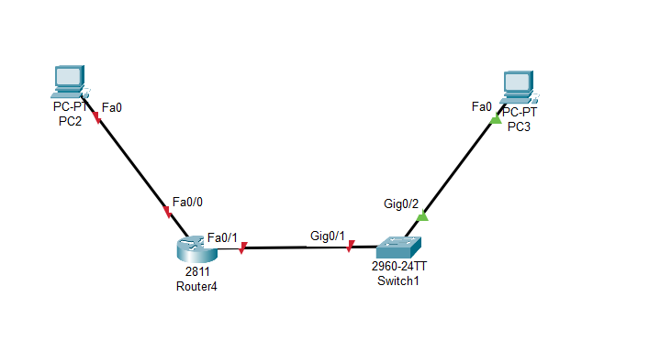

### Configuration:

IP config of PC2:

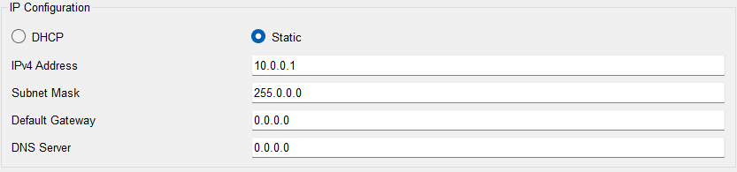

IP config of Router -FastEthernet 0/0:

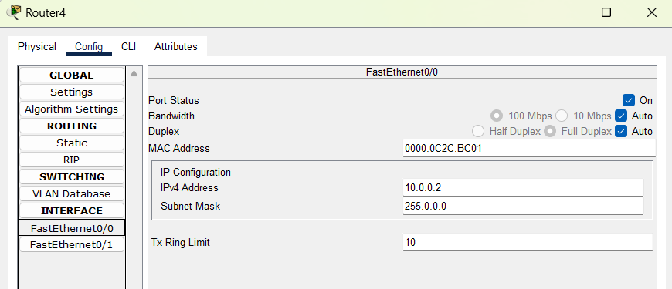

IP config of Router -FastEthernet 0/1:

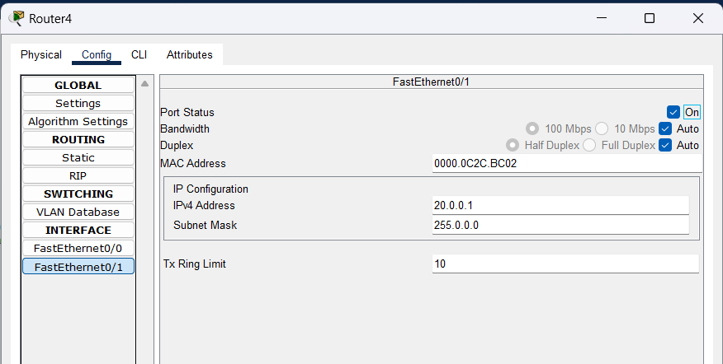

IP config of PC:

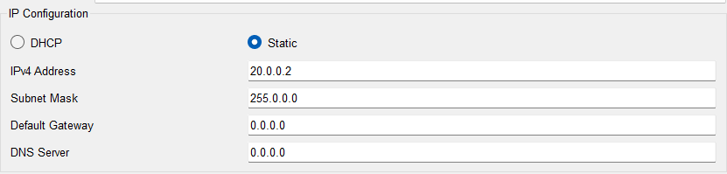

### Testing for connections:

Checking Connection between pc2 and router fastethernet 0/0

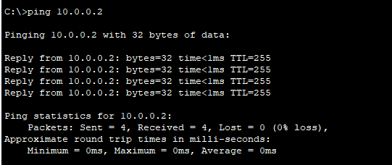

Checking Connection between router fastethernet 0/1 and pc3

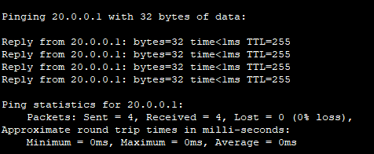

Checking Connection between pc3 to router fastethernet 0/0

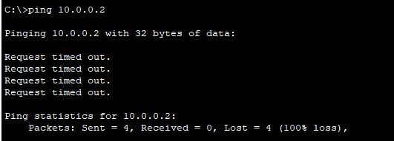

Checking Connection between pc2 to pc3

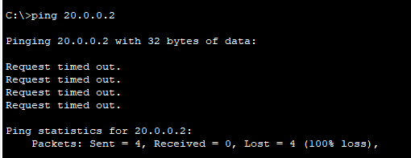

From the above connections following to be noticed:

* When we connect devices between the same network i.e, between 10.0.0.1 and 10.0.0.2 or between 20.0.0.1 and 20.0.0.2, the connection is success.
* But when we try to connect to different networks like the connection between 10.0.0.1 and 20.0.0.2, the connection is failed.

To build a connection between different networks we need to config our PC gateway accordingly:

For PC2:

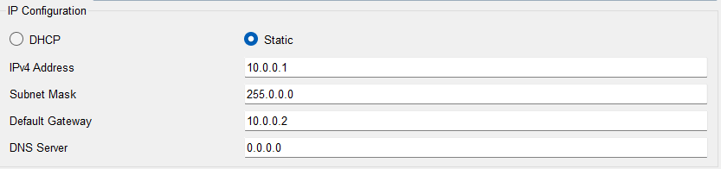

For PC3:

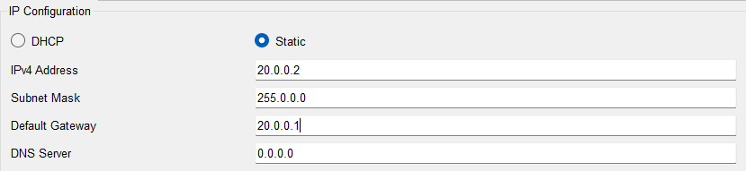

Now again trying to connect pc2 to pc3:

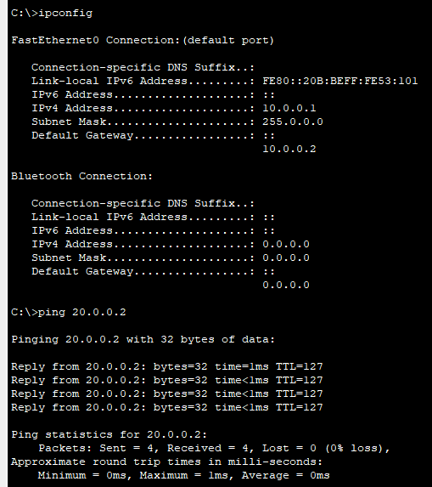

## Connection between same devices (Router - Router)

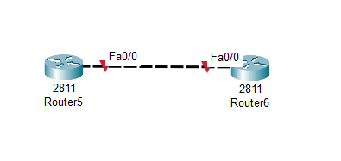

### Configuration:

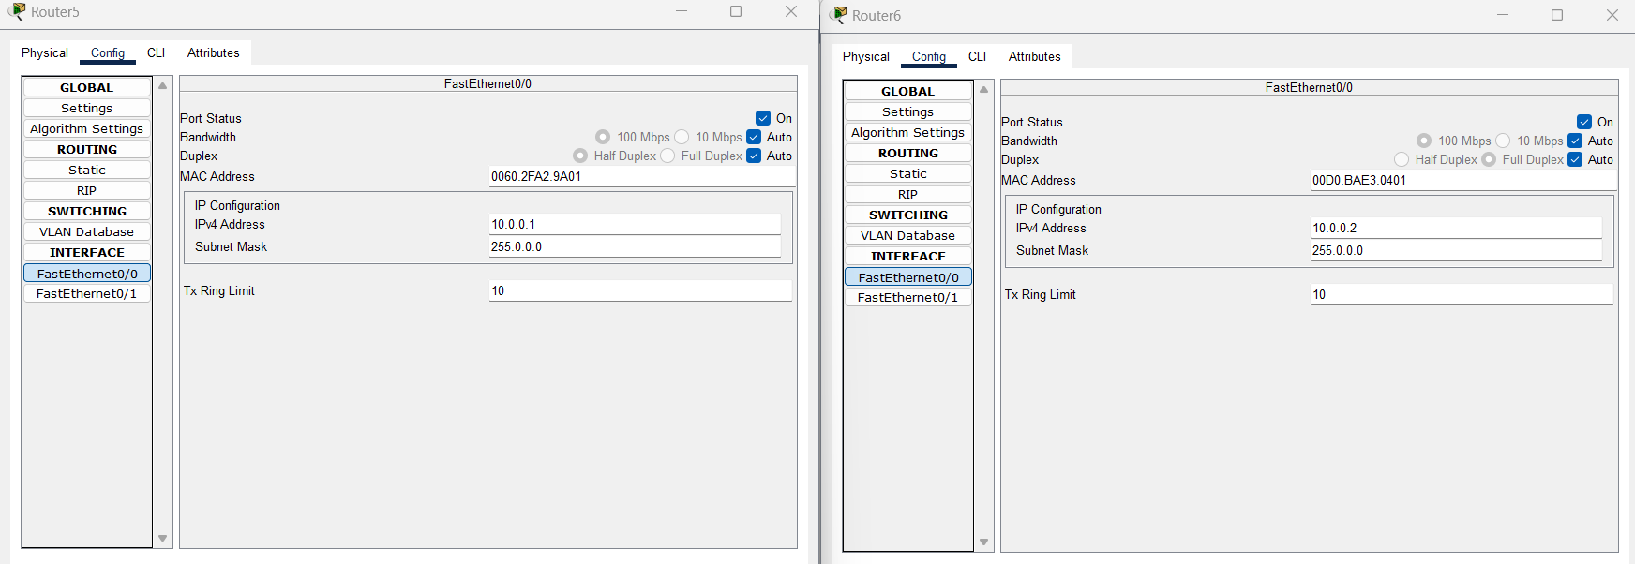

### Testing for connections:

